Click on Create Project

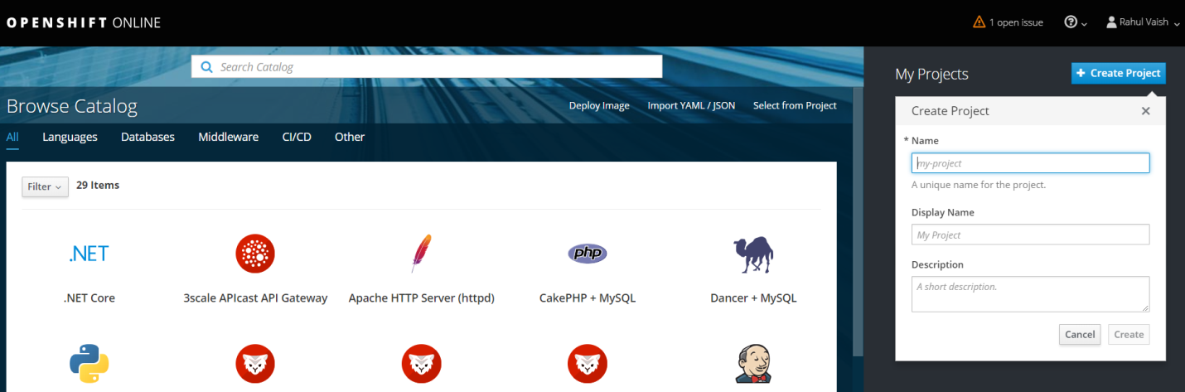

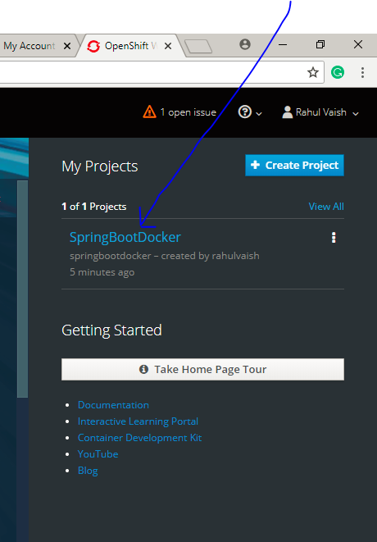

Click on SpringBootDocker Project, the below screen appears-

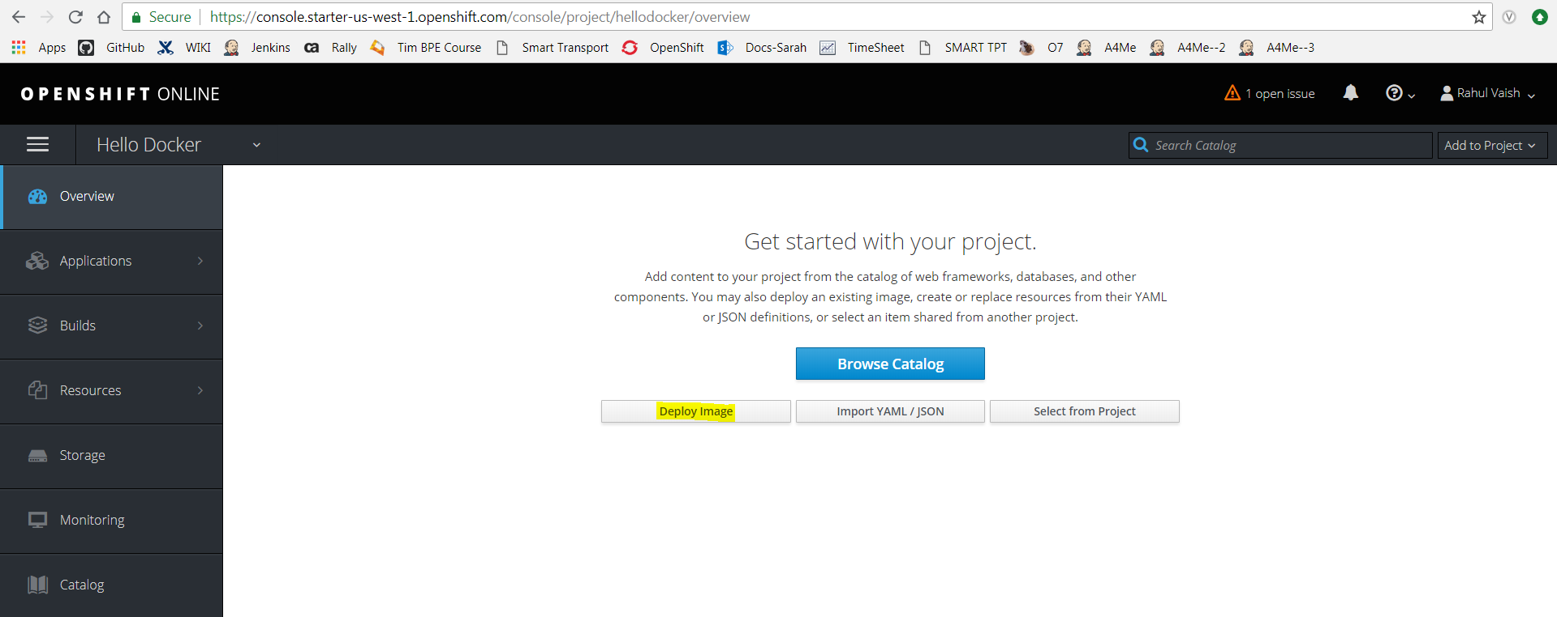

When above screen opens, click on “Deploy Image” button, the below screen appears –

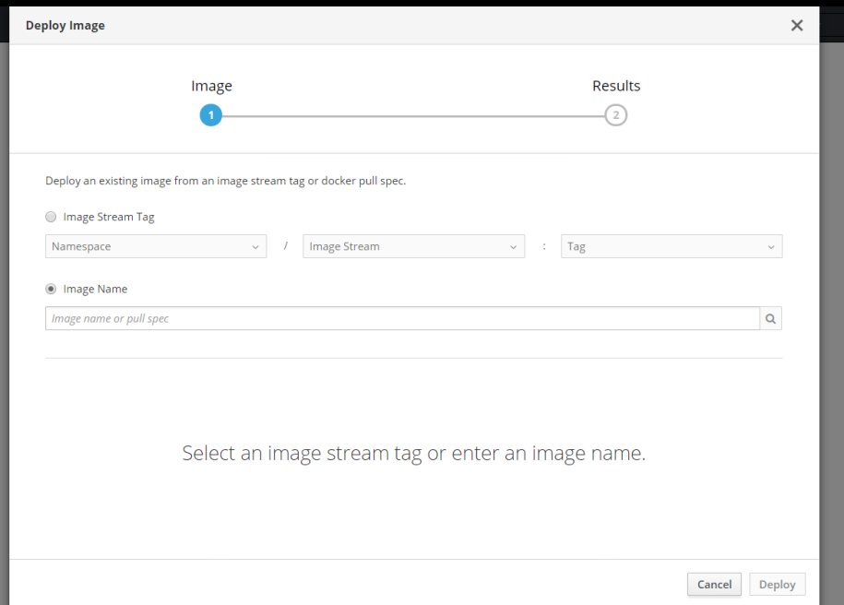

To get the image name, open **hub.docker.com (below),** copy the highlighted part **(below)** and paste it in the Image field name **(above)** and hit enter.

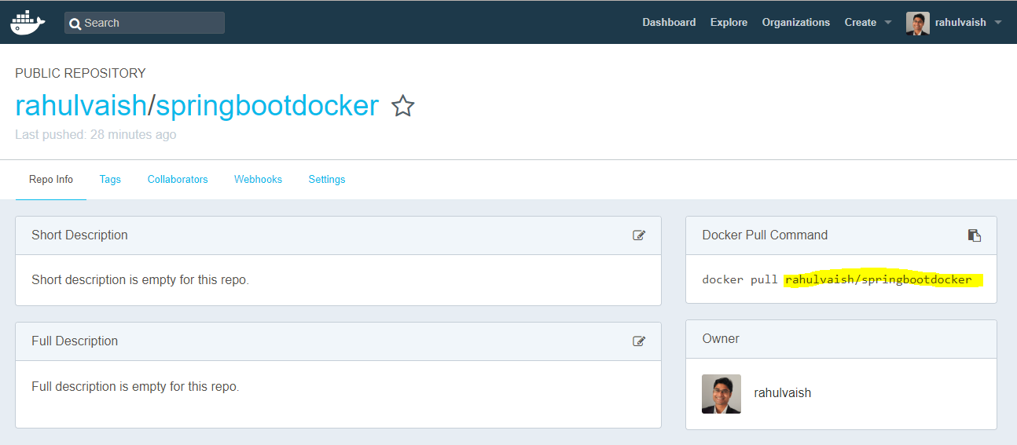

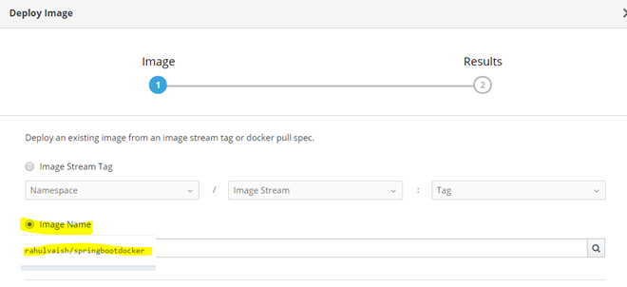

Click on deploy (button in the same window)

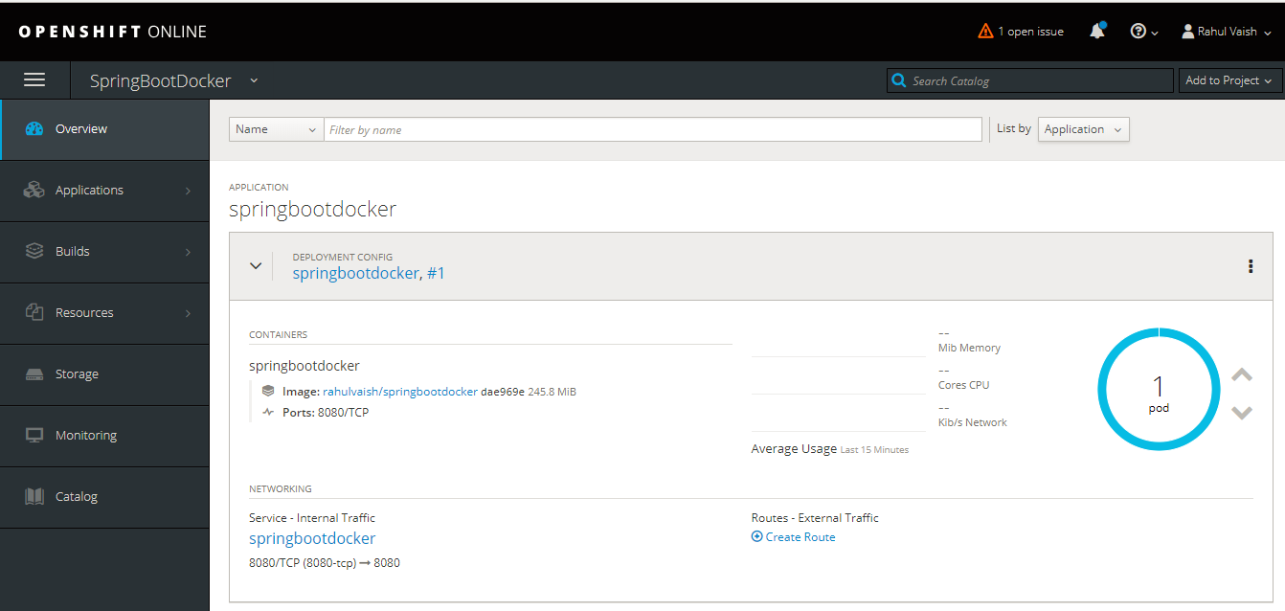

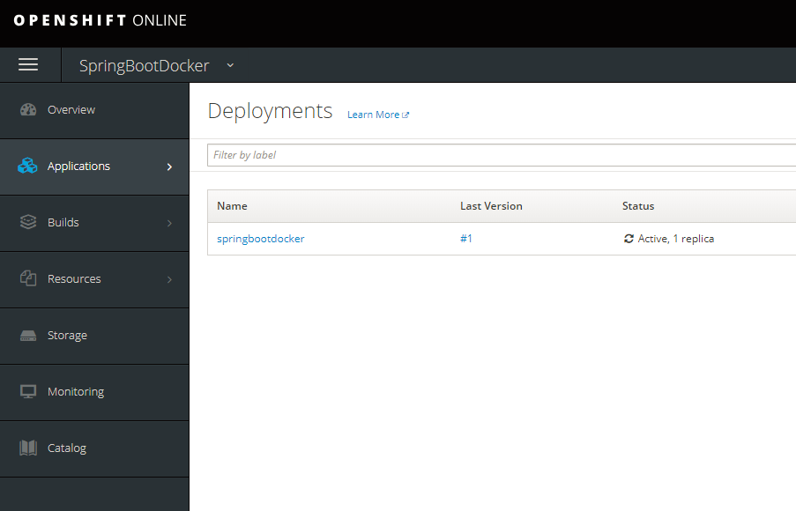

Click on #1

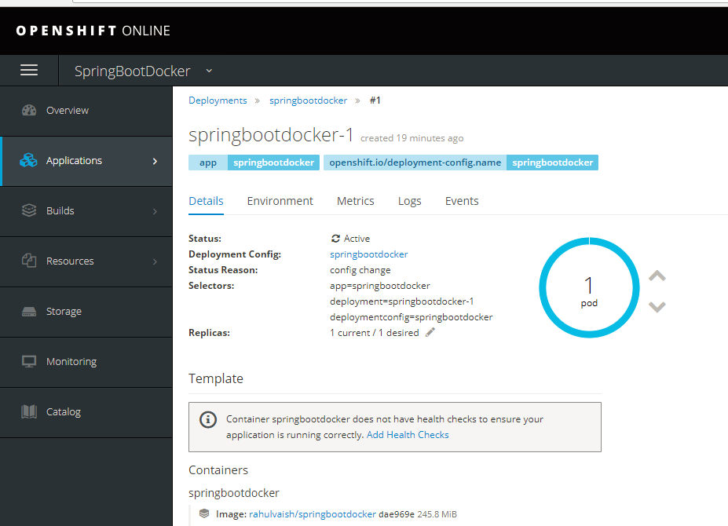

Select “Logs” from above screen to get the below:

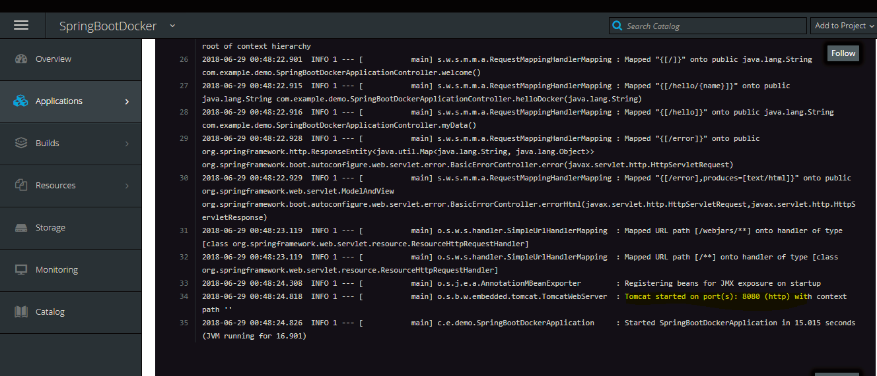

Now, on the dashboard, there is a link to “CREATE ROUTE”, just create a route and system will prepare a router like this –

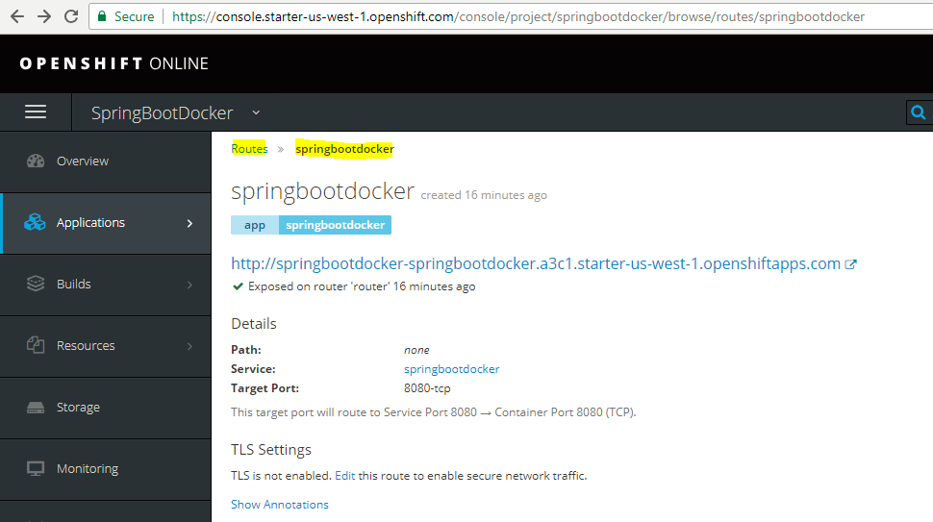

And if you click on this link **:D** WOW **:D**

